Set up Oracle ASM on an Azure Linux virtual machine

Contents

**In this Guide** 1

Prepare the environment 2

Connect to the VM 2

Install Oracle ASM 2

Set up Oracle ASM 4

**Download and prepare Oracle Grid Infrastructure** 8

**Prepare your local client and VM to run x11** 10

**Install Oracle Grid Infrastructure** 15

**Set up your Oracle ASM installation** 20

**Create the database** 24

**Delete the VM** 26

**Next steps** 26

# In this Guide

Azure virtual machines provide a fully configurable and flexible computing environment. This tutorial covers basic Azure virtual machine deployment combined with the installation and configuration of Oracle Automated Storage Management (ASM). You learn how to:

* Install and configure Oracle Automated Storage Management
* Install and configure Oracle Grid infrastructure
* Initialize an Oracle ASM installation
* Create an Oracle DB managed by ASM

If you choose to install and use the CLI locally, this tutorial requires that you are running the Azure CLI version 2.0.4 or later. Run az --version to find the version. If you need to install or upgrade, see [Install Azure CLI](https://docs.microsoft.com/en-us/cli/azure/install-azure-cli).

# Prepare the environment

This documentation assumed you already have an Azure VM deployed and followed steps to prepare it for an Oracle Database. If you haven’t done this, ensure you’ve performed all steps from **<insert document link here>,** including creating a resource group, deploying the VM, setting up users, permissions and adding storage in preparation for the next steps in this document.

Your version of ASM instance must be the same or greater to the Oracle database that it supports. An 18c ASM instance can’t support a 19c Oracle database, but a 19c ASM instance can support an 18c Oracle database.

Although there is support documentation available on new features, the latest administration guide available from Oracle as of the time this document was authored is [Oracle 18c ASM Administration Guide](https://docs.oracle.com/en/database/oracle/oracle-database/18/ostmg/index.html).

# Connect to the VM

If you aren’t already connected with an SSH session using a terminal emulator such as Azure Cloud Shell or Putty, you’ll need to connect to the VM and configure additional settings using the publicIpAddress value for your VM.

ssh <publicIpAddress>

# Install Oracle ASM

Ensure you are logged in as root to perform the ASM installation:

whoami

If the response isn’t “root”, switch to the root user:

sudo su -

List, download and install the Oracle ASM downloads

yum list | grep oracleasm

yum -y install kmod-oracleasm.x86_64

yum -y install oracleasm-support.x86_64

wget https://download.oracle.com/otn_software/asmlib/oracleasmlib-2.0.12-1.el6.x86_64.rpm

yum -y install oracleasmlib-2.0.12-1.el6.x86_64.rpm

rm -f oracleasmlib-2.0.12-1.el6.x86_64.rpm

Verify that Oracle ASM is installed:

rpm -qa |grep oracleasm

The output of this command should list the following components:

oracleasm-support-2.1.10-4.el6.x86_64

kmod-oracleasm-2.0.8-15.el6_9.x86_64

oracleasmlib-2.0.12-1.el6.x86_64

ASM requires specific users and roles in order to function correctly. The following commands create the pre-requisite user accounts and groups. If you followed the document for setting up an Oracle Enterprise Linux server for Oracle, the users and roles can be verified with the following commands:

id oracle

The correct output should look like the following:

uid=501(oracle) gid=54321(oinstall) groups=54321(oinstall),54329(asmadmin),54327(asmdba),54322(dba)

Check the grid control users and roles for ASM are prepared:

id grid

The correct output of this command should list the following users and groups:

uid=3000(grid) gid=54321(oinstall) groups=54321(oinstall),54329(asmadmin),54327(asmdba),54328(asmoper),54322(dba)

Create a folder for user *grid* and change the owner:

mkdir /u01/app/ # This directory may already exist

mkdir /u01/app/grid

chown grid:oinstall /u01/app/grid

# Set up Oracle ASM

For this tutorial, the default user is *grid* and the default group is *asmadmin*. Ensure that the *oracle* user is part of the asmadmin group. To set up your Oracle ASM installation, complete the following steps:

/usr/sbin/oracleasm configure -i

Setting up the Oracle ASM library driver involves defining the default user (grid) and default group (asmadmin) as well as configuring the drive to start on boot (choose y) and to scan for disks on boot (choose y). You need to answer the prompts and the responses will look like the following:

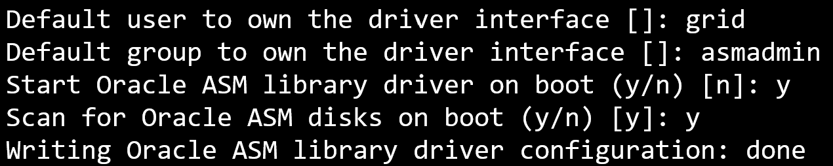

Once this is complete, it will be time to inspect the disks that are available and to be configured by ASM.

View the disk configuration:

cat /proc/partitions

The output of this command should look similar to the following listing of available disks:

11 0 628 sr0

8 16 14680064 sdb

8 17 14678976 sdb1

8 0 31457280 sda

8 1 512000 sda1

8 2 30944256 sda2

2 0 4 fd0

8 32 134217728 sdc

8 48 1048576000 sdd

8 64 276824064 sde

In the example above, three disks were added for the following:

* sdc: 264g for the ASM disk for ASM use
* sdd: 1000g for the data disk for datafiles
* sde: 128g for the redo disk for redo logs

Format disk */dev/sdc* by running the following command and answering the prompts with:

* + *n* for new partition
  + *p* for primary partition
  + *1* to select the first partition. If we wanted to create more than one partition from the disk, we could number them and partition the disk in smaller sections.
  + press enter for the default first cylinder
  + press enter for the default last cylinder
  + press *w* to write the changes to the partition table

fdisk /dev/sdc

Using the answers provided above, the output for the fdisk command should look like the following:

Device contains not a valid DOS partition table, or Sun, SGI or OSF disklabel

Building a new DOS disklabel with disk identifier 0xf865c6ca.

Changes will remain in memory only, until you decide to write them.

After that, of course, the previous content won't be recoverable.

Warning: invalid flag 0x0000 of partition table 4 will be corrected by w(rite)

The device presents a logical sector size that is smaller than

the physical sector size. Aligning to a physical sector (or optimal

I/O) size boundary is recommended, or performance may be impacted.

WARNING: DOS-compatible mode is deprecated. It's strongly recommended to

switch off the mode (command 'c') and change display units to

sectors (command 'u').

Command (m for help): n

Command action

e extended

p primary partition (1-4)

p

Partition number (1-4): 1

First cylinder (1-6527, default 1):

Using default value 1

Last cylinder, +cylinders or +size{K,M,G} (1-6527, default 6527):

Using default value 6527

Command (m for help): w

The partition table has been altered!

Calling ioctl() to re-read partition table.

Syncing disks.

For our example, we repeat the preceding fdisk command for /dev/sdd, /dev/sde and for any ASM configuration, we would do this for any disks the environment may require.

Check the disk configuration:

cat /proc/partitions

The output of the command should look like the following:

11 0 628 sr0

8 16 14680064 sdb

8 17 14678976 sdb1

8 0 31457280 sda

8 1 512000 sda1

8 2 30944256 sda2

2 0 4 fd0

8 32 134217728 sdc

8 33 134216704 sdc1

8 48 1048576000 sdd

8 49 1048574976 sdd1

8 64 276824064 sde

8 65 276823040 sde1

Check the Oracle ASM service status and start the Oracle ASM service:

oracleasm status

The output of the command should look like the following:

Checking if ASM is loaded: no

Checking if /dev/oracleasm is mounted: no

oracleasm init

Creating /dev/oracleasm mount point: /dev/oracleasm

Loading module "oracleasm": oracleasm

Configuring "oracleasm" to use device physical block size

Mounting ASMlib driver filesystem: /dev/oracleasm

Create Oracle ASM disks:

oracleasm createdisk ASMSP /dev/sdc1

The output of the command should look like the following:

Writing disk header: done

Instantiating disk: done

This must be performed for each of the disks:

oracleasm createdisk data /dev/sdd1

oracleasm createdisk redo /dev/sde1

List Oracle ASM disks:

oracleasm listdisks

The output of the command should list off the following Oracle ASM disks:

ASMSP

DATA

REDO

Change the passwords for the root, oracle, and grid users. **Make note of these new passwords** as you are using them later during the installation.

passwd oracle

passwd grid

passwd root

Change the folder permission:

chmod -R 775 /opt

chown grid:oinstall /opt

chown oracle:oinstall /dev/sdc1

chown oracle:oinstall /dev/sdd1

chown oracle:oinstall /dev/sde1

chmod 600 /dev/sdc1

chmod 600 /dev/sdd1

chmod 600 /dev/sde1

# Download and prepare Oracle Grid Infrastructure

To download and prepare the Oracle Grid Infrastructure software, complete the following steps:

Download Oracle Grid Infrastructure from the appropriate version of Oracle that you plan on installing:

* [Oracle 12c](https://www.oracle.com/database/technologies/oracle12c-linux-12201-downloads.html)
* [Oracle 18c](https://www.oracle.com/database/technologies/oracle18c-linux-180000-downloads.html)
* [Oracle 19c](https://www.oracle.com/database/technologies/oracle19c-linux-downloads.html)

Depending on the version of Oracle you’re installing, there may be 1 or 2 zip files that need to be first downloaded, then copied over to the VM. In our example, 19c will be used:

After you download the .zip files to your client computer, you can use Secure Copy Protocol (SCP) to copy the files to your VM. If you’re using SSH keys for authentication, use the [following link](https://docs.microsoft.com/en-us/azure/virtual-machines/linux/mac-create-ssh-keys?toc=/azure/virtual-machines/linux/toc.json) if in need of assistance before connecting and transferring of files:

scp linux.x64_19300_home.zip <publicIpAddress>:.

SSH back into your Oracle VM in Azure in order to move the .zip files into the /opt folder. Then, change the owner of the files:

ssh <publicIPAddress>

sudo mv ./*.zip /opt

cd /opt

sudo chown grid:oinstall LINUX.X64_193000_grid_home.zip

Unzip the files. (Install the Linux unzip tool if it's not already installed.)

sudo yum install unzip

sudo unzip LINUX.X64_193000_grid_home.zip

** Create directory and change permission:

sudo mkdir /opt/grid

sudo chown -R grid:oinstall /opt/grid

Update configured swap space. Oracle Grid components need at least 6.8 GB of swap space to install Grid. The default swap file size for Oracle Linux images in Azure is only 2048MB. You need to increase ResourceDisk.SwapSizeMB in the /etc/waagent.conf file and restart the WALinuxAgent service in order for the updated settings to take effect. Because it is a read-only file, you need to change file permissions to enable write access.

sudo chmod 777 /etc/waagent.conf

vi /etc/waagent.conf

Search for the following two parameters:

* ResourceDisk.EngableSwap
* ResourceDisk.SwapSizeMB

The first parameter will need to be changed from “n” to “y” update the swap size to **8192**.

# Create and use swapfile on resource disk.

ResourceDisk.EnableSwap=y

# Size of the swapfile.

ResourceDisk.SwapSizeMB=8192

Use the editor of your choice and once completed, save the file and exit.

Note

*We highly recommend that you always use WALinuxAgent to configure swap space so that it's always created on the local ephemeral disk (temporary disk) for best performance. For more information on, see* [*How to add a swap file in Linux Azure virtual machines*](https://support.microsoft.com/en-us/help/4010058/how-to-add-a-swap-file-in-linux-azure-virtual-machines)*.*

# Prepare your local client and VM to run x11

Configuring Oracle ASM requires a graphical interface to complete the install and configuration. We are using the x11 protocol to facilitate this installation. If you are using a client system (Mac or Linux) that already has X11 capabilities enabled and configured - you can skip this configuration and setup exclusive to Windows machines.

[Download PuTTY](https://www.putty.org/) and [download Xming](https://xming.en.softonic.com/) to your Windows computer. You will need to complete the installation of both of these applications with the default values before proceeding.

*Note:* [*This*](https://docs.microsoft.com/en-us/azure/virtual-machines/linux/use-remote-desktop) *may be an option instead of Xming/Putty if you’re using Redhat or other Linux distribution for the UI installation of Grid Control.*

After you install PuTTY, open a command prompt, change into the PuTTY folder (for example, C:\Program Files\PuTTY), and run puttygen.exe in order to generate a key.

In PuTTY Key Generator:

* 1. Generate a key by selecting the Generate button.
  2. Copy the contents of the key (Ctrl+C).
  3. Select the Save private key button.
  4. Ignore the warning about securing the key with a passphrase, and then select OK.

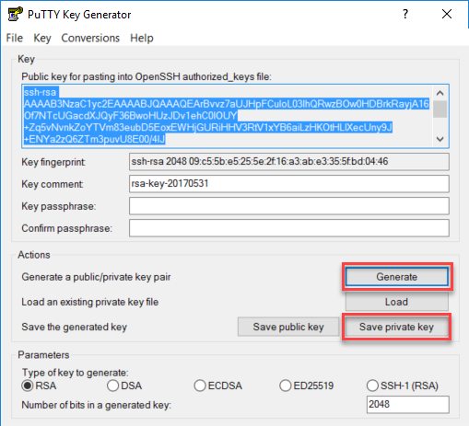

In your VM, run these commands:

sudo su - grid

mkdir .ssh

cd .ssh

Create a file named authorized_keys. Paste the contents of the key in this file, and then save the file.

*Note: The key must contain the string ssh-rsa. Also, the contents of the key must be a single line of text.*

On your client system, start PuTTY. In the **Category** pane, go to **Connection** > **SSH** > **Auth**. In the **Private key file for authentication** box, browse to the key that you generated earlier.

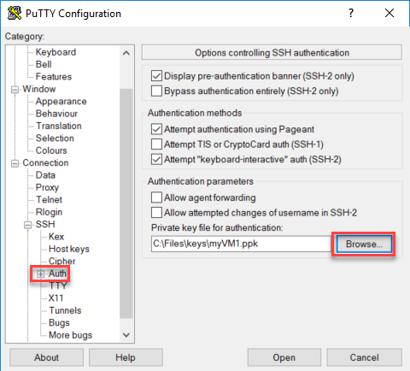

In the **Category** pane, go to **Connection** > **SSH** > **X11**. Select the **Enable X11 forwarding** check box.

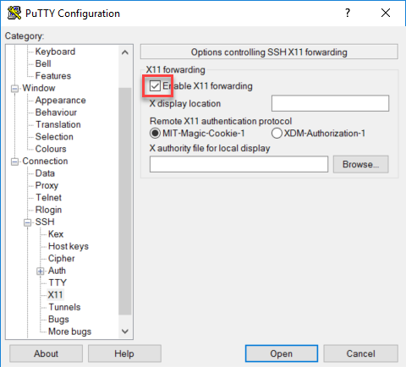

In the **Category** pane, go to **Session**. Enter your Oracle ASM VM <publicIPaddress> in the host name dialog box, fill in a new Saved Session name and then click on Save. Once saved, click on open to connect to your Oracle ASM virtual machine. The first time you connect you are warned the remote system is not cached in your registry. Click on yes to add it and continue.

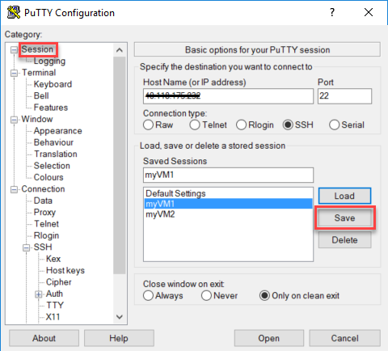

# Install Oracle Grid Infrastructure

To install Oracle Grid Infrastructure, complete the following steps:

Sign into the VM and switch over to the Root user.

Note

*If you are running Windows, make sure you have started Xming before you begin the installation.*

cd /opt

mv /opt/LINUX.X64_193000_grid_home.zip /opt/grid/.

cd /opt/grid

chown * grid:oinstall

su – grid

The next steps MUST be run as the GRID user.

./gridSetup.sh

If you receive the following:

ERROR: Unable to verify the graphical display setup. This application requires X display. Make sure that xdpyinfo exist under PATH variable.

Check to verify that xdpyinfo is installed. It’s often missing from the images and it’s used for this check. If missing, you’ll receive an error and it will need to be installed if found to be missing:

xdpyinfo

-bash: xdpyinfo: command not found

sudo install xdpyinfo

Add it to the path if it’s missing:

export PATH=$PATH:/bin/xdpyinfo

No X11 DISPLAY variable was set, but this program performed an operation which requires it.

export DISPLAY=<workstation IP Address>0.0

The Oracle Grid Infrastructure Installer opens. (It might take a few minutes for the installer to start.)

On the **Select Installation Option** page, select **Install and Configure Oracle Grid Infrastructure for a Standalone Server**.

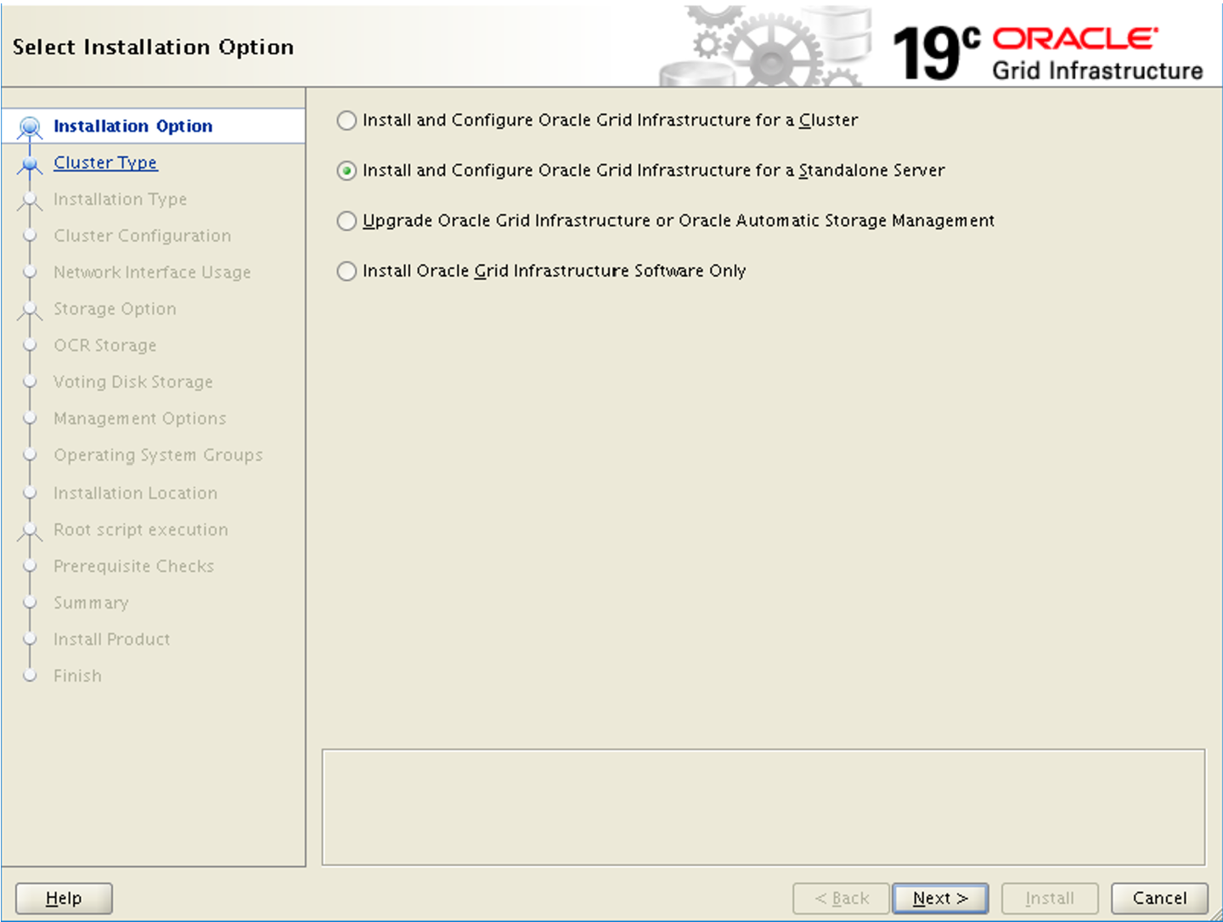

On the **Select Product Languages** page, ensure **English** or the language that you want is selected. Click next.

On the **Create ASM Disk Group** page:

* + Enter a name for the disk group.
  + Under **Redundancy**, select **External**.
  + Under **Allocation Unit Size**, select **4**.
  + Under **Add Disks**, select **ORCLASMSP**.
  + Click next.

On the **Specify ASM Password** page, select the **Use same passwords for these accounts** option, and enter a password.

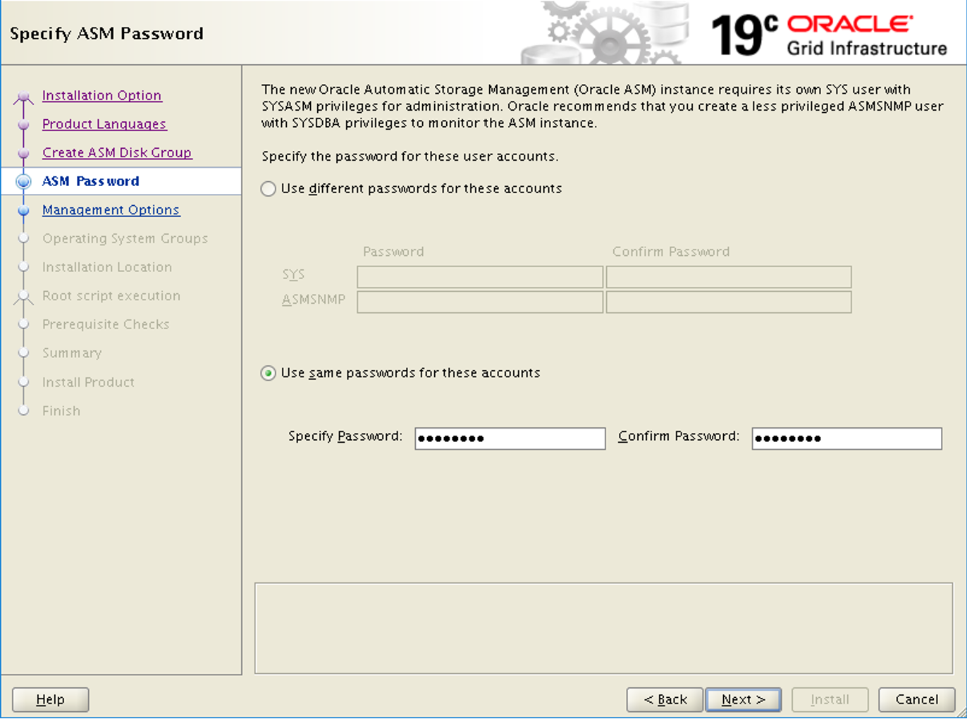

On the **Specify Management Options** page, you have the option to configure EM Cloud Control. We are skipping this option - click next to continue.

On the **Privileged Operating System Groups** page, use the default settings. Click next to continue.

On the **Specify Installation Location** page, use the default settings. Click next to continue.

On the **Create Inventory** page, change the Inventory Directory to /u01/app/grid/oraInventory. Click next to continue.

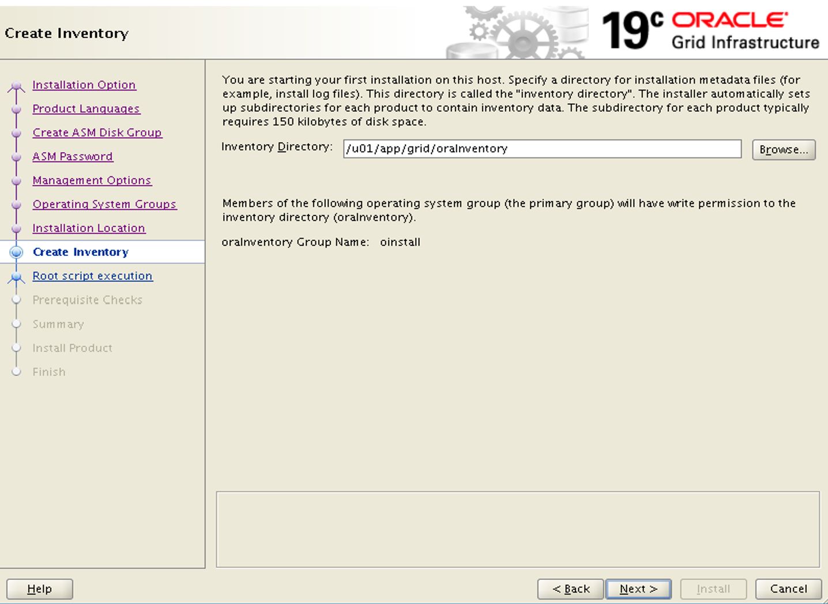

On the **Root script execution configuration** page, select the **Automatically run configuration scripts** check box. Then, select the **Use "root" user credential** option, and enter the root user password.

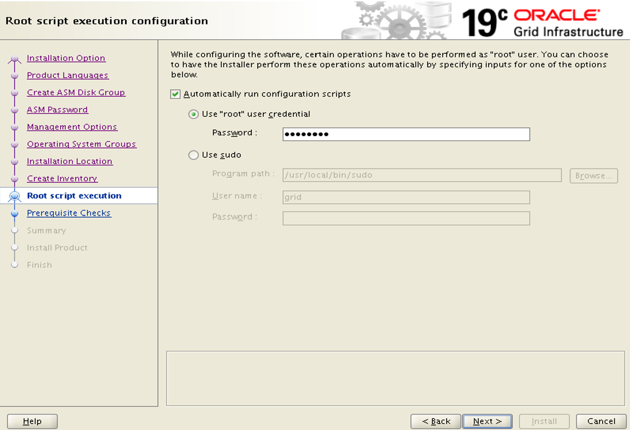

On the **Perform Prerequisite Checks** page, the current setup will fail with errors. This is an expected behavior. Select Fix & Check Again.

In the **Fixup Script** dialog box, click OK.

On the **Summary** page, review your selected settings, and then click Install.

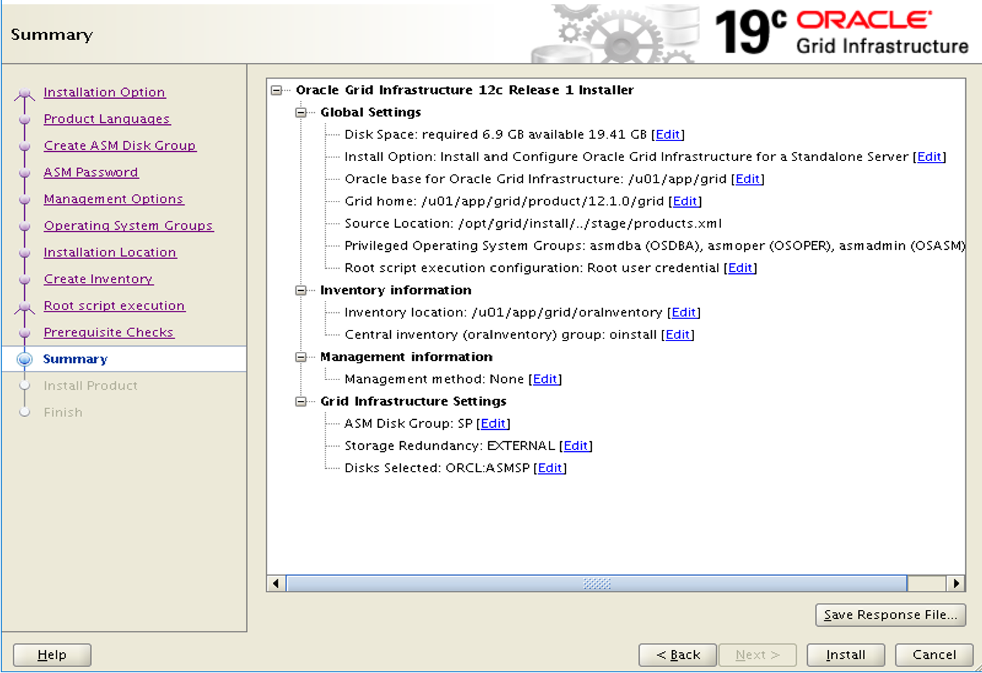

A warning dialog box appears informing you configuration scripts need to be run as a privileged user. Click Yes to continue.

On the **Finish** page, click Close to finish the installation.

# Set up your Oracle ASM installation

To set up your Oracle ASM installation, complete the following steps:

Ensure you are still signed in as **grid**, from your X11 session. You might need to hit enter to revive the terminal. Then launch the Oracle Automated Storage Management Configuration Assistant:

cd /u01/app/grid/product/12.1.0/grid/bin

./asmca

Oracle ASM Configuration Assistant opens.

In the **Configure ASM: Disk Groups** dialog box, click the Create button, and then click Show Advanced Options.

In the **Create Disk Group** dialog box:

* + Enter the disk group name **DATA**.
  + Under **Select Member Disks**, select **ORCL_DATA** and **ORCL_DATA1**.
  + Under **Allocation Unit Size**, select **4**.
  + Click ok to create the disk group.
  + Click ok to close the confirmation window.

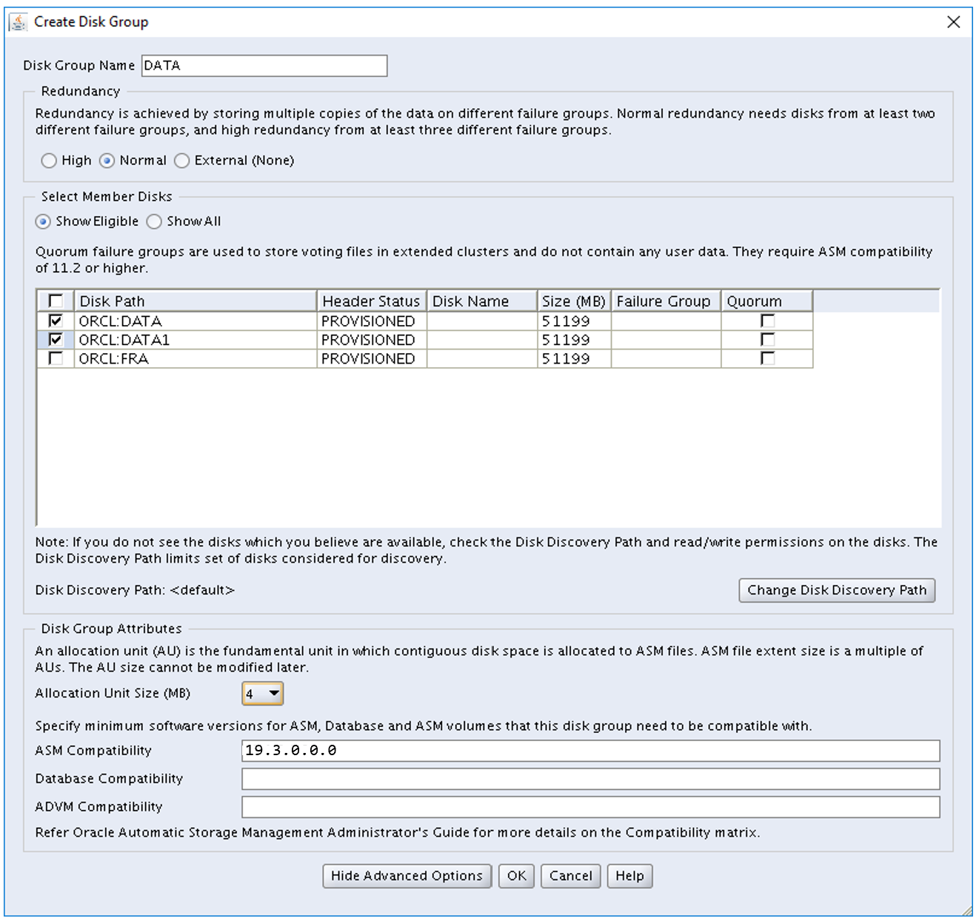

In the **Configure ASM: Disk Groups** dialog box, click the Create button, and then click Show Advanced Options.

In the **Create Disk Group** dialog box:

* + Enter the disk group name **FRA**.
  + Under **Redundancy**, select **External (none)**.
  + Under **Select Member Disks**, select **ORCL_FRA**.
  + Under **Allocation Unit Size**, select **4**.
  + Click ok to create the disk group.
  + Click ok to close the confirmation window.

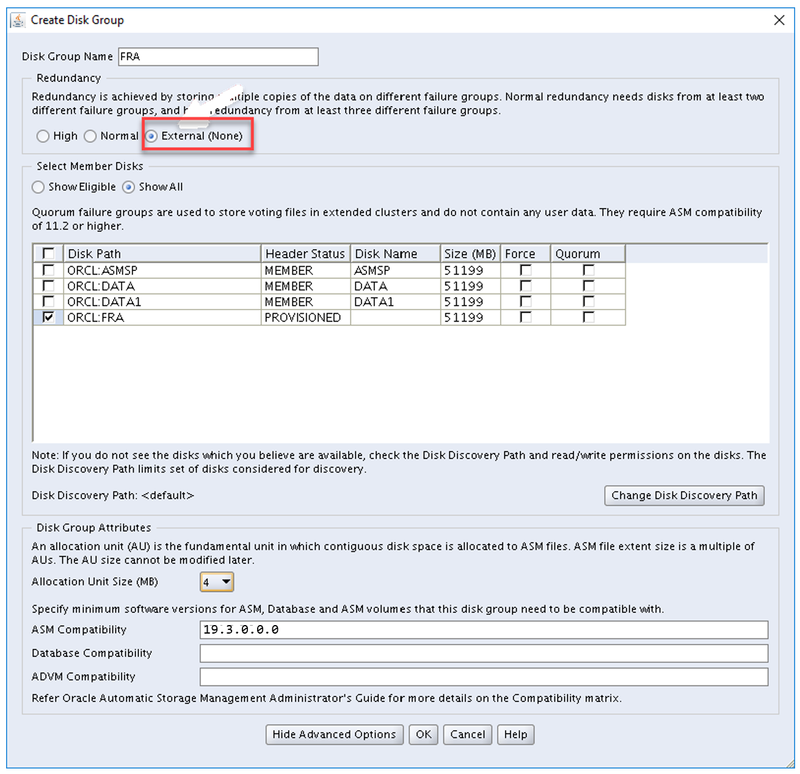

Select **Exit** to close ASM Configuration Assistant.

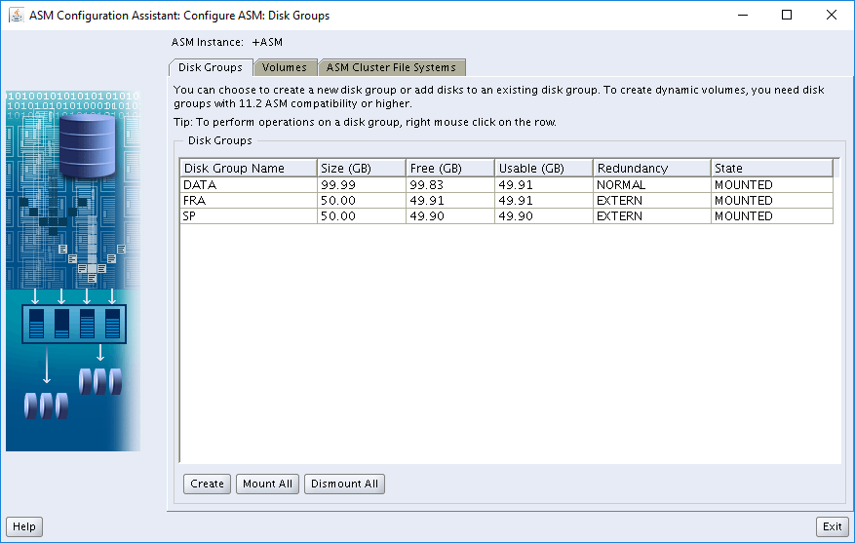

# Create the database

The Oracle database software is already installed on the Azure Marketplace image. To create a database, follow the instructions in the following link. For ASM specific setting, ensure to use the following:

* + For **Storage Type**, ensure **Automatic Storage Management (ASM)** is selected.
  + For **Database Files Location**, use the default ASM suggested location.
  + For **Fast Recovery Area**, use the default ASM suggested location.

This completes the ASM installation and configuration. For further information, refer to the [Oracle ASM Administration](https://docs.oracle.com/en/database/oracle/oracle-database/18/ostmg/index.html) guide.

**Delete the VM**

You have successfully configured Oracle Automated Storage Management on the Oracle DB image from the Azure Marketplace. When you no longer need this VM, you can use the following command to remove the resource group, VM, and all related resources:

Azure CLICopy

az group delete --name myResourceGroup

**Next steps**

[Tutorial: Configure Oracle DataGuard](https://docs.microsoft.com/en-us/azure/virtual-machines/workloads/oracle/configure-oracle-dataguard)

[Tutorial: Configure Oracle GoldenGate](https://docs.microsoft.com/en-us/azure/virtual-machines/workloads/oracle/configure-oracle-golden-gate)

Review [Architect an Oracle DB](https://docs.microsoft.com/en-us/azure/virtual-machines/workloads/oracle/oracle-design)